Feb 6, 2016

1,

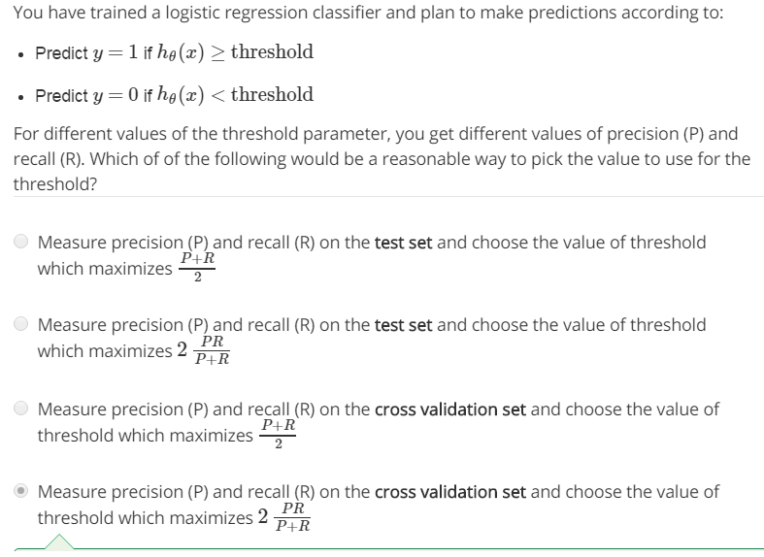

2,